DIY 59

1.Go to Jenkins, download a plugin with the name Deploy to Container

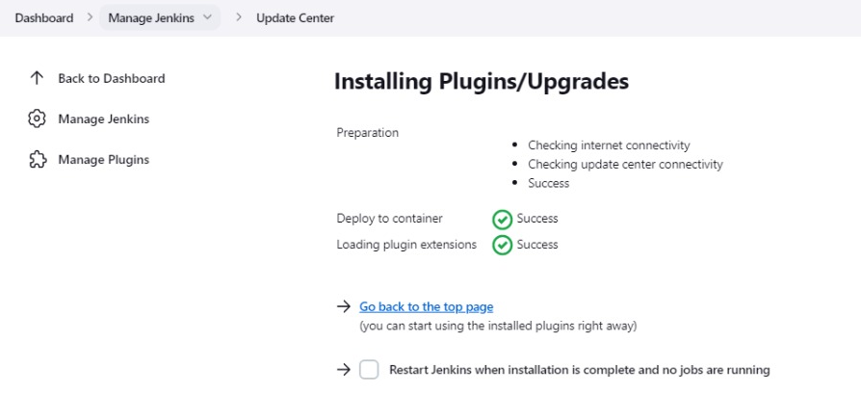

2.Create a freestyle Jenkins job with the name as DeployCode



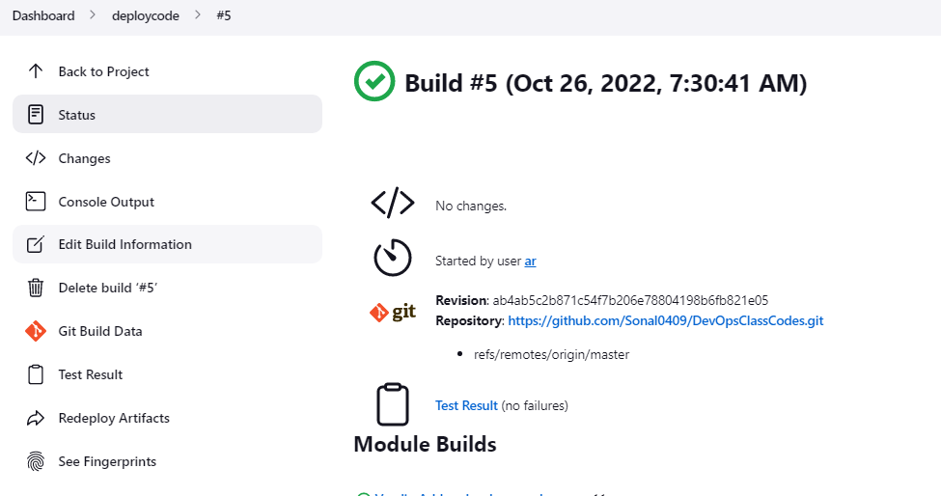

3.Take a java code from GitHub and

deploy it on the tomcat server.

